Project structure and organization
Creation of project
- The quickest way to create a new Next.js app is using create-next-app, which sets up everything automatically for you. To create a project, run:
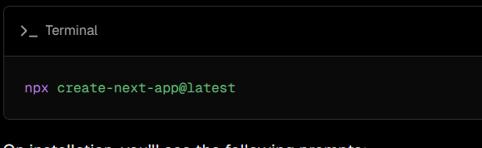
- cd my-app and start the dev server.
- Visit http://localhost:3000.

Folder and file conventions
Top-level folders
- Top-level folders are used to organize your application's code and static assets.
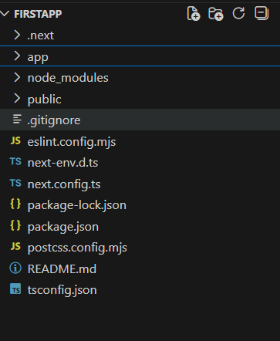

app | App Router
pages | Pages Router

Top-level files
Top-level files are used to configure your application, manage dependencies, run proxy, integrate monitoring tools, and define environment variables.

next.config.js | Configuration file for Next.js
package.json | Project dependencies and scripts
instrumentation.ts | OpenTelemetry and Instrumentation file
proxy.ts | Next.js request proxy
.env | Environment variables
.env.local | Local environment variables
.env.production | Production environment variables
.env.development | Development environment variables
eslint.config.mjs | Configuration file for ESLint
.gitignore | Git files and folders to ignore
next-env.d.ts | TypeScript declaration file for Next.js
tsconfig.json | Configuration file for TypeScript
jsconfig.json | Configuration file for JavaScript

Routing Files
Add page to expose a route, layout for shared UI such as header, nav, or footer, loading for skeletons, error for error boundaries, and route for APIs.
layout | .js .jsx .tsx | Layout
page | .js .jsx .tsx | Page
loading | .js .jsx .tsx | Loading UI
not-found | .js .jsx .tsx | Not found UI
error | .js .jsx .tsx | Error UI
global-error | .js .jsx .tsx | Global error UI
route | .js .ts | API endpoint
template | .js .jsx .tsx | Re-rendered layout
default | .js .jsx .tsx | Parallel route fallback page

